

z

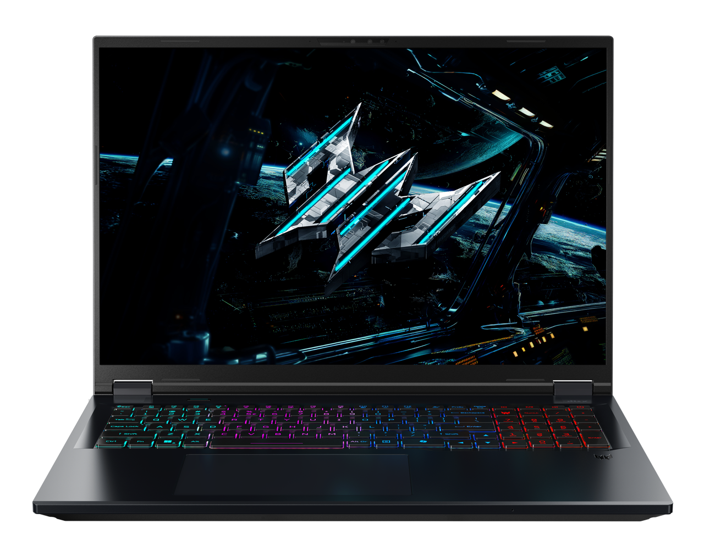

PREDATOR HELIOS NEO 18 AI

SPECIFICATIONS PREDATOR HELIOS NEO 18 AI PHN18-I71

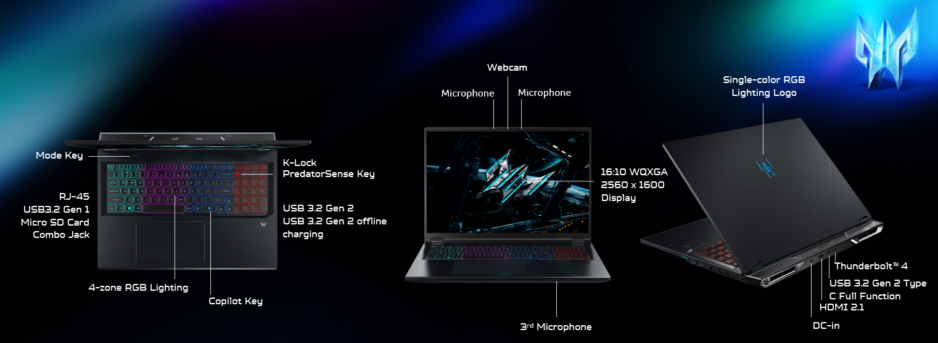
Operating System |  | Windows 11 Home
CPU and Chipset |  | Intel® Core™ Ultra 9 processor 290HX Plus  Intel® Core™ Ultra 7 processor 270HX Plus
Memory |  | Up to 64 GB of DDR5 system memory using four soDIMM modules | Memory Frequency : Up to 6400 MT/s  Dual-channel DDR5 SDRAM support
Display |  | 18.0" display with IPS (In-Plane Switching) technology | WQXGA 2560 x 1600 | Acer ComfyView™ LED-backlit TFT LCD | 500 nits brightness | 240 Hz refresh rate | 3 ms grey-to-grey response time by overdrive | NVIDIA® Advanced Optimus capable  16:10 aspect ratio | 100% DCI-P3 color gamut  Wide viewing angle up to 170 degrees  Ultra-slim design  Mercury free, environment friendly |  | 18.0" display with IPS (In-Plane Switching) technology | WQXGA 2560 x 1600 | Acer ComfyView™ LED-backlit TFT LCD | 300 nits brightness | 165 Hz refresh rate | 3 ms grey-to-grey response time by overdrive | NVIDIA® Advanced Optimus capable  16:10 aspect ratio | 100% DCI-P3 color gamut  Wide viewing angle up to 170 degrees  Ultra-slim design  Mercury free, environment friendly
Graphics |  | NVIDIA® GeForce RTX™ 5080 16 GB GDDR7  NVIDIA® GeForce RTX™ 5070 Ti 12 GB GDDR7  NVIDIA® GeForce RTX™ 5070 Ti 8 GB GDDR7  NVIDIA® GeForce RTX™ 5060 Ti 8 GB GDDR7
Audio |  | Audio  DTS® X:Ultra Audio | Optimized bass | Loudness enhancement | Speaker protection via smart amplifier | Up to 6 custom content modes  High-SNR DAC | 2.1 Vrms output | Drives high-impedance headphones up to 600 Ω  Compatible with Cortana voice commands | Spatial Audio & Voice Processing  Windows Spatial Sound for PC Gaming | DTS Sound Unbound license integrated  Acer Purified Voice with AI noise reduction | Triple microphone array | Far-field voice pickup | Neural network noise suppression | Adaptive beamforming | Personal and conference call modes | Advanced privacy mode |  |  | Audio Enhancements & Certification  Immersive audio rendering for headphones and internal speakers  Acer TrueHarmony technology | Reduced distortion | Wider frequency range | Headphone-like audio output | Enhanced speaker performance  Hi-Res Audio certified by JAS | Headphone output supported up to 24-bit / 192 kHz
Storage |  | Solid state drive: (2 slots): 512 GB / 1 TB / 2 TB, PCIe Gen4, 16 Gb/s, NVMe
Webcam |  | Video Conferencing  UFC with narrow USB FHD camera and IR camera | Blue glass lens | 1920 x 1080 resolution | 1080p video with temporal noise reduction | Staggered High Dynamic Range (SHDR) | Dual microphones (33 mm + 33 mm) | 88 x 3.2 x 2.6 mm | Windows compatible only
Wireless and Networking |  | WLAN:  Killer™ Wireless Wi-Fi 6E 1675i  802.11 a/b/g/n/ac/ax wireless LAN  Band: 2.4 GHz, 5 GHz and 6 GHz  2x2 MU-MIMO technology  Support CNVi interface | LAN:  Killer™ Ethernet E3100G  2.5G Ethernet  Killer Control Center  Lag and Latency Reduction™ Technology  Advanced Stream Detect™2.0  Killer DoubleShot™ Pro enabled  GameFast™ Technology |  |  | WPAN:  Supports Bluetooth® 5.4 or above  Supports Bluetooth LE Audio (LC3)
Security |  | Firmware Trusted Platform Module (TPM) solution | BIOS user, supervisor passwords | Kensington lock slot
Dimensions and Weight |  | Dimensions  400.96 (W) x 307.9 (D) x 14.9/28 (H) mm (15.79 x 12.12 x 0.59/1.1 inches)  Weight  3.3 kg (7.28 lbs.) with 4-cell battery pack |  |  | (Notes: iX1_ARX Dimension ( Thermal moduel FAN different)  1. B1 : 400.96 x 307.9 x 23.6 ~ 28.05 mm  2. B2 : 400.96 x 307.9 x 23.6 ~ 25.2 mm )
Power Adapter and Battery |  | Power Adapter  3-pin 330 W 5.5 PHY PCR 50% AC adapter  185.0 (W) x 85.0 (D) x 31.0 (H) mm (7.28 x 3.35 x 1.22 inches)  19.5 V / 16.9 A as output power  900 g ± 10%, with 180 cm DC cable  Black color with Acer logo  Brick - type AC pins | Battery  92 Wh 4-cell Li-ion battery  For models with WQXGA Panel  Battery life:  Up to 5 hours (based on MobileMark® 2025 test results)  Up to 8 hours (based on video playback test results)
Input and Control |  | Keyboard  103 (US) / 104 (UK) keys | FineTip RGB-backlit keyboard | Independent numeric keypad | International language support  2.0 mm key travel  Caps Lock indicator | Microphone mute indicator  Function Lock switchable on ESC key | Touchpad  Multi-gesture touchpad | Two-finger scroll | Pinch gesture | Gestures to open Cortana | Action Center | Multitasking | Application commands  Microsoft Precision Touchpad certification  Moisture resistant |  |  | Control Keys  Acer My Key design  Dedicated PredatorSense key  Microsoft Copilot key
Windows Desktop Apps |  | In-House Applications  Acer AlterView | Acer LiveArt | Acer QuickPanel | Acer VisionArt | PredatorSense V5 (NB) |  | Tools  Acer My Key Application
Warranty |  | One-year International Travelers Warranty (ITW)
Disclaimers
• | Specifications vary depending on model.
• | Shared system memory may be allocated to support graphics, depending on system memory size and other factors. Actual system memory available to the operating system will be reduced by any memory used by the graphics solution and resources required by the operating environment.
• | Memory speed may vary, depending on the CPU, chipset or memory fitted.
• | All brands and product names mentioned herein include trademarks of their respective companies and are used solely to describe or identify the products.
• | 1 GB is 1 billion bytes. Actual formatted capacity is less and may vary depending on preloaded materials and operating environment. Acer Recovery Management uses a portion of the stated hard disk capacity as dedicated backup space.
• | Minor variations in system dimensions are possible due to the manufacturing process.
• | Weight may vary depending on product configuration, vendor components, manufacturing variability, and selected options.
• | Listed battery life is based on testing using video playback. The test clip loops and continues to run, without interruption or any other inputs, until the battery is drained. Stated battery life is for comparison purpose only. Actual battery life varies by model, configuration, applications, video chip format and features used. A battery's maximum capacity decreases with time and use. Battery life test configuration: 15th Gen Intel® Core U9 Refresh, NVIDIA® GeForce RTX™ 5060, WQXGA, SSD only, 64GB of DDR5 memory. Battery life test condition: LCD brightness 150 nits, connected headphones, WLAN off, Bluetooth off and Better Battery Mode on.
• | Actual battery life may vary considerably by specifications, depending on product model, configuration, applications, power management settings, operating conditions, and features utilized. Performance variation also arises based on components in use, which includes but is not limited to the processor, RAM capacity, storage, display and resolution, etc.
• | Bundled software may vary depending on hardware configuration, OS and regional availability.

Product sheet specification based on Predator PHN18-I71 Specifications (v3-0-2) (Preview

In a continuing effort to improve the quality of our products, information in this document is subject to change without notice. Images shown are only representations of some of the configurations available for this model. Availability may vary depending on region. As a phenomenon known to thin-film transistors (TFTs), liquid crystal displays (LCDs) commonly exhibit a small number of discoloration dots, as so-called "non-conforming pixels." This phenomenon is a limitation of TFT LCD technology, not a product defect, and as such is not covered by Acer's warranty.
© 2026. All rights reserved.Microsoft and Windows are registered trademarks of Microsoft Corporation.
3D XPoint, Agilex, Altera, Arc, Arria, Avalon, Axxia, Barefoot Networks, the Barefoot logo, the Footsie logo, Celeron, Cyclone, Docae, DoubleShot, eASIC, easicopy, FlexRAN, Gaudi, Granulate, HyperFlex, Intel, the Intel logo, Intel Adapix, Intel Agilex, Intel Atom, Intel Cofluent, Intel Core, Intel Evo, Intel Geti, Intel Inside, the Intel Inside logo, Intel Optane, Intel RealSense, Intel SpeedStep, Intel Tiber, Intel Unison, Intel vPro, Iris, Killer, Linux, MAX, Movidius, Myriad, Nios, OmniBridge, OpenVINO, the OpenVINO logo, Pentium, Quartus, Simics, SmartByte, SoFiaSilicon, Sound Mark, StarPro, Stay With It, the Engineering Stay With It logo, Stratix, the Stratix logo, the Journey Inside, Thunderbolt, the Thunderbolt logo, Tofino, Ultrabook, VTune, and Xeon are trademarks of Intel Corporation or its subsidiaries.

About Acer
Founded in 1976, Acer is one of the world's top ICT companies with a presence in more than 160 countries. As Acer evolves with the industry and changing lifestyles, it is focused on enabling a world where hardware, software and services will fuse with one another, creating ecosystems and opening up new possibilities for consumers and businesses alike. Acer's 7,500 employees are dedicated to the research, design, marketing, sale, and support of products and solutions that break barriers between people and technology. Please visit www.acer.com for more information.

